Lesson 5: Consumer and producer surplus

What is Consumer Surplus?
The difference between the total value of the goods purchased and the total price paid for those goods is known as consumer surplus (CS). Graphically it is the area under the demand curve and above the purchase price up to the # of units purchased.[1]
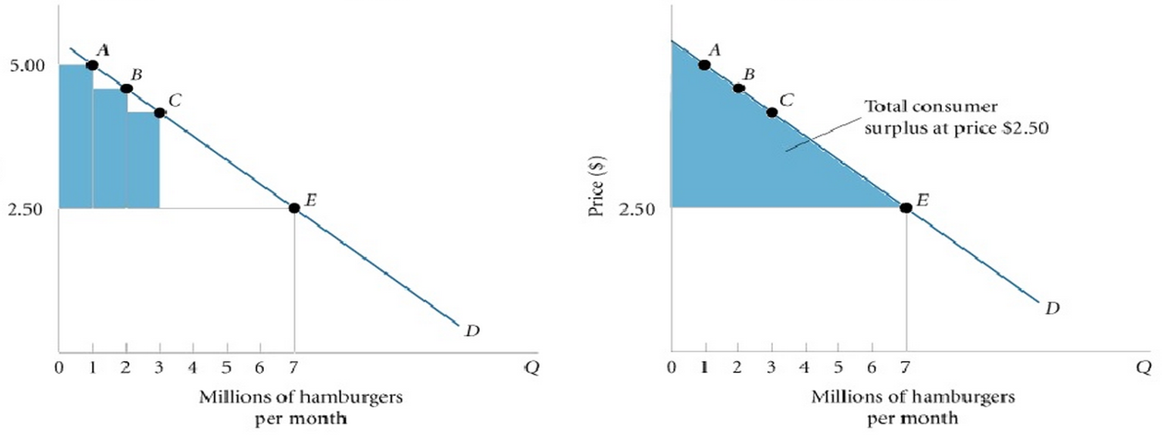
Mathematically:
Consumer Surplus = Value of Units Consumed − Price Paid to purchase those units
Consumer Surplus = 0.5(Base x Height)= 0.5[Q₀*(Y_{intercept} − P₀ )]

As you can see, Consumer A was willing to pay $5 for a hamburger but only had to pay $2.50. Their individual consumer surplus is equal to that difference. If we add each consumers difference up to the quantity sold we get the consumer surplus of the entire market.
Note that in this interpretation we are treating the demand curve as the marginal benefit curve because it shows the highest price that buyers are willing to pay for each additional unit. As the quantity of goods owned increases the marginal demand or willingness to pay for an incremental unit decreases (see utility theory).

Defining Producer Surplus
Producer surplus (PS) is similar to consumer surplus but from the perspective of the suppliers. It is the difference between the price producers receive for the total number of sold goods and the cost they pay to produce those goods. That is:
Producer Surplus = Total Revenue − −Total variable cost of producing the quantity sold
Producer Surplus = 0.5(base * height) = 0.5[Q₀ * (P₀ − Y_{intercept} )]
Where total revenue = # of units sold * price per unit.
Graphically, if we assume perfect competition, the supply curve can be interpreted as the marginal cost curve, where marginal cost is defined as the lowest price at which a seller is willing to sell the next unit of a good.
Producer surplus is shown as the area above the marginal cost curve and below the price line up to the quantity produced.[2]
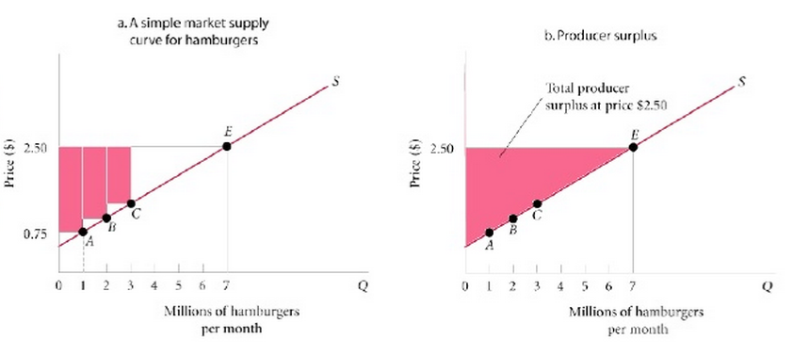
Producer A’s cost of goods is $0.75 but they’re able to sell for $2.50. That extra $1.75 is their individual producer surplus.

Total Surplus/Social Welfare - The Sum of CS and PS
Total surplus is the sum of the consumer and producer surplus. We can think of it as the net value to society, or social welfare:
Total Surplus = consumer surplus + producer surplus
As total surplus increases, social welfare goes up.
Note that in a competitive market the area of maximum social welfare occurs at market equilibrium where Qs = Qd (i.e. where Price = Marginal Cost).
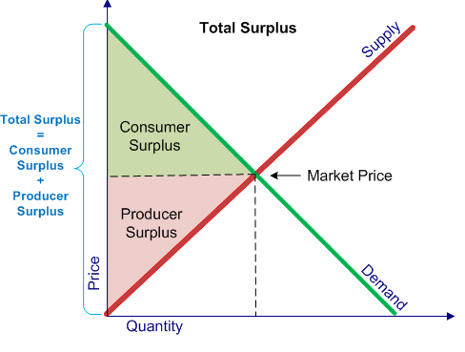
That is, the supply curve represents marginal cost and the demand curve represents marginal benefit and competition drives us towards an efficient equilibrium that allocates resources efficiently.
The division of total surplus between consumers and suppliers is an important indicator for the nature of the market. From the standpoint of equality and bargaining power alike, we care about whether consumers or producers are benefitting more.
To determine the answer we look at the relative steepness of the supply and demand curves.
- When supply curve is steeper than the demand curve, PS > CS
- When the demand curve is steeper than the supply curve, CS > PS

